Project Design Phase-II

Solution Requirements (Functional & Non-functional)
Date: 26 June 2025
Team ID: 111111
Project Name: Classification of Fabric Patterns using Deep Learning
Maximum Marks: 4 Marks

Functional Requirements:
FR No. | Functional Requirement (Epic) | Sub Requirement (Story / Sub-Task)
FR-1 | Image Upload | 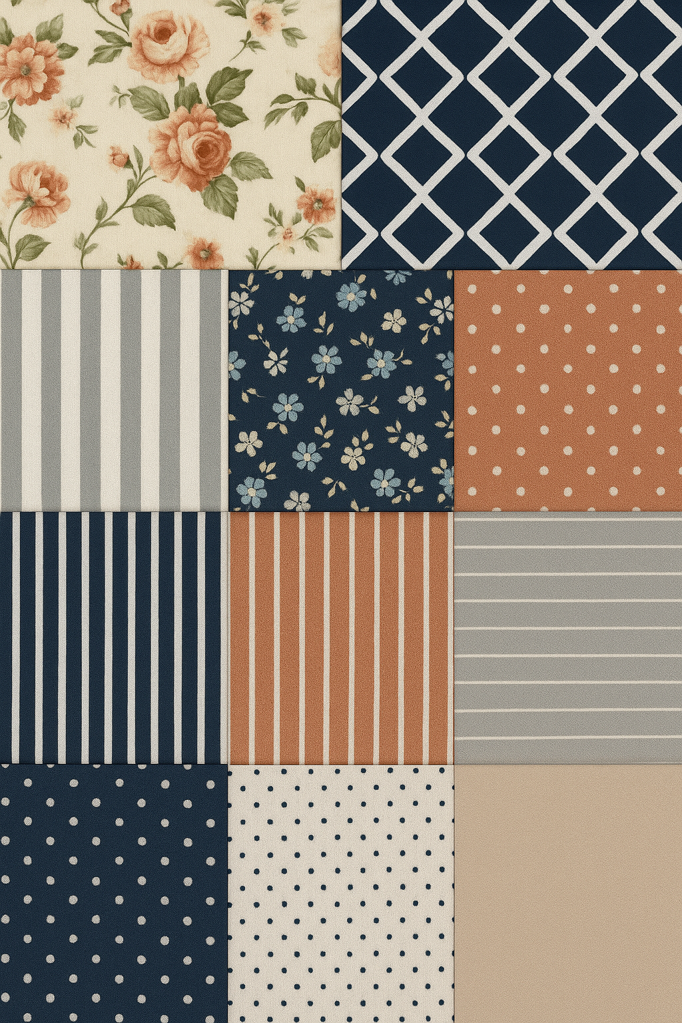
 |  | Capture via mobile camera
FR-2 | Pattern Classification | Perform real-time pattern detection using deep learning model
 |  | Display prediction with confidence score
FR-3 | Result Management | 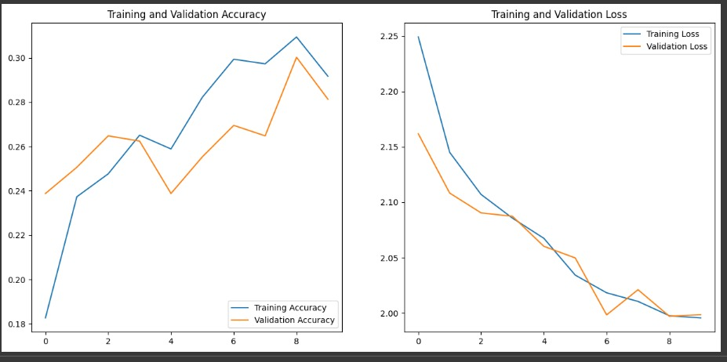
FR-4 | History View | Show list of previously classified patterns
FR-5 | Feedback | Allow users to correct or flag wrong classification
FR-6 | Admin Management | Add, delete, or update user data
 |  | Upload updated deep learning model

Non-functional Requirements:
FR No. | Non-Functional Requirement | Description
NFR-1 | Usability | Interface should be simple and intuitive for mobile and web users
NFR-2 | Security | Secure login, data encryption, and access control
NFR-3 | Reliability | System should perform classification accurately and consistently
NFR-4 | Performance | Classification should occur within 2-3 seconds of image upload
NFR-5 | Availability | System should be accessible 24/7 with minimal downtime
NFR-6 | Scalability | Should handle increasing number of users and data uploads efficiently

